**Frontend Development with React.js**

**Project Documentation for FitFlex(Fitness app)**

1. **Introduction**

* Project Title: FitFlex(fitness app)
* Team members:

* Divya sri S(Team Leader) [Email Id: [sreekuttysekar023@gmail.com](mailto:sreekuttysekar023@gmail.com)]

[Team Leader for this project Ensuring the project output and collaborating with other team members.]

* Jayasri R [Email Id: [jayasri24904@gmail.com](mailto:jayasri24904@gmail.com)]

[Team member Planning Organizing and executing the project. Troubleshooting technical issues and offering solution for that.]

* Lathika S [Email Id: [lathikasureshkumarlathika@gmail.com](mailto:lathikasureshkumarlathika@gmail.com)]

[Team member Test the product for bugs report defects and ensure quality control and also created the demo video for this project]

* Mythili N [Email Id: [mythilinambi22@gmail.com](mailto:mythilinambi22@gmail.com)]

[Team member Managed the documentation for this project. Keeps the design consistent with the project’s brand identity and goals.]

1. **Project Overview**

* **Purpose:**

To provide an easy to use platform that helps users stay fit and

Motivated.

To integers fitness,nutrition and mental well being in a single app.

* **Goals:**

Promotes Healthy Lifestyles

Personlized workout plans

Suggest Equipments to the exercise**.**

1. **Architecture**

* **Components Structure:**

The **Footer.jsx**  component could display legal information,links to social media or any other bottom content.

The **About.jsx** components is typically used to provide some information about the application such as what it does, how it works or who created it.

A **Homesearch.jsx**  components could be a feature that allows users to search for execises,workouts or fitness resources directly from the home page.

**Hero.jsx components is typically the first prominent section of the** user interface that appears when someone lands on the homepage or the app’s main screen.

* **State management:**

It is used to perform interactivity, consistency and communication.[Eg.contextAPI]

* **Routing:**

Routing refers to process of determining which component should be displayed based on the URL.

1. **Setup Instructions**

* **Prerequisites:**

This project requires Node.js to run. It also comes with npm, which is used to install the dependencies.

Need a code editor to work on the project. By using Visual Studio Code as used this project.

* **Installation:**

Install Node.js & npm

Make sure you have Node.js and npm installed. These are required to install dependencies and run the application.

* If you don’t have them installed, visit the Node.js Website and download the LTS version.

Install the dependencies by running this command:

npm install

* This command read the package.json file in you project and installs all the libraries listed there(like React, ReactRouter,etc.)

1. **Folder Structure**

* **Client:**

The client folder is where all the React-related files live, including components, pages, styles and static assets. It follows a common structure that makes it easy to maintain and scale the app. Key components are organized into separate folders for better readability and reusability.

* **Utilities:**

The utilities folder is essential for making your React application modular, clean and easier to maintain. It centralizes reusable logic that can be accessed throughout the app, such as API calls, date formatting, validation and other helper functions

1. **Running the application**

* **Frontend:**

The frontend of your fitness website is built using React.js which is a popular JavaScript library for building user interfaces. The frontend is responsible for everything the user interacts with the visual elements, the navigation and the user experience.

The frontend of your fitness website is built with React.js and follows a component based architecture, where each part of the UI is split into reusable components.React Router is used for navigation, while CSS(or SCSS) provides the styling.

1. **Component Documentation**

This component documentation provides an overview of the major components in your fitness website project. Each components has a specific role, such as user interface elements (Button, WorkoutCard), for elements(TextInput) or full page components (Loginpage and profilepage). These components are designed to be reusable and modular, following best practices in React development.

* **Key Components:**

Navbar: Main navigation links to sections(Home, Workouts, Profile, Login).

Homepage: Introduction to the website and featured workouts.

Login/Signup page: Authentication for users to create or access their accounts.

Workout Details Page: Detailed information for each specific workout.

Profile Page: User’s personal profile and workout progress.

Workout Tracker: A tool to track completed workouts and progress.

API Integration: Backend API to fetch and submit data(workouts, user, data etc).

Footer: Contains additional links and information for the website.

* **Reusable Components:**

Reusable components are essential for maintain a clean, efficient and scalable codebase. These components are designed to be used in multiple parts of the application, allowing for a consistent user interface and simplifying code maintenance. By breaking down the UI into smaller, modular components, we avoid repetition and make the code easier to manage.

The Button component is a reusable UI elements that can be used throughout the site wherever a button is needed, such as in forms, workout cards or navigation. It accepts props like text, onClick and style, which allow it to be customized based on its context. For instance, it can be used in the Homepage to start a workout session or in the Loginpage to submit user credentials.

1. **State Management**

* **Global State:**

Global state plays a crucial role in managing shared data across various components, Instead of passing data manually through props from parents to child components(which can become tedious and inefficient as the project grows),global state allows for centralized data management that can be accessed from any part of the application. This ensures that critical data, such as user authentication status, workout progress and user preferences is consistently available across the entire application without unnecessary duplication.

* **Local State:**

Local state refers to data that is specific to a particular component in a React application and is typically managed using Reacts built in useState hook. Unlike global state, which is shared across multiple components, local state is confined to a single component and is used for managing data that doesn’t need to be shared across the entire app.

1. **User Interface**

The User Interface(UI) of the fitness website is the part of the application that users interact with directly. It is designed to provide a seamless and user-friendly experience while helping users navigate through various features of the site, such as discovering workouts, tracking progress and managing their fitness goals.

1. **Styling**

* **CSS Framework/Libraries:**

CSS framework and libraries help speed up development by providing pre-built styles, components and utilities.

Bootstrap

Tailwind

* **Theming:**

Colour scheme

For this project we want to use dark and intense colour for the background is used to evoke strength and determination.

Bold and strong fonts

Is used to emphasizing strength and confidence.

* UI/UX elements

Minimalist Navigation like Home, About, Search; Call-to-action button is used to “view more”

**11.Testing**

* **Testing Strategy**

It is to ensure that all functionality works as intended, the website provides an optimal user experience and it is robust across various devices and browsers.

**Unit Testing**

Test individual functions and methods in the codebase to ensure they perform their intended actions.

* **Code Coverage:**

It refers to a metric used to determine the percentage of your codebase that is tested by your automated tests. A high level of code coverage means thjat you are testing most of your applications functionality, which helps catch potential issues before they make it to production.

Fitflex Website project, achieving good code coverage can help ensure that all features—such as registration, workout plans, progress tracking, payment systems and user authentication.

1. **Screenshots or Demo**

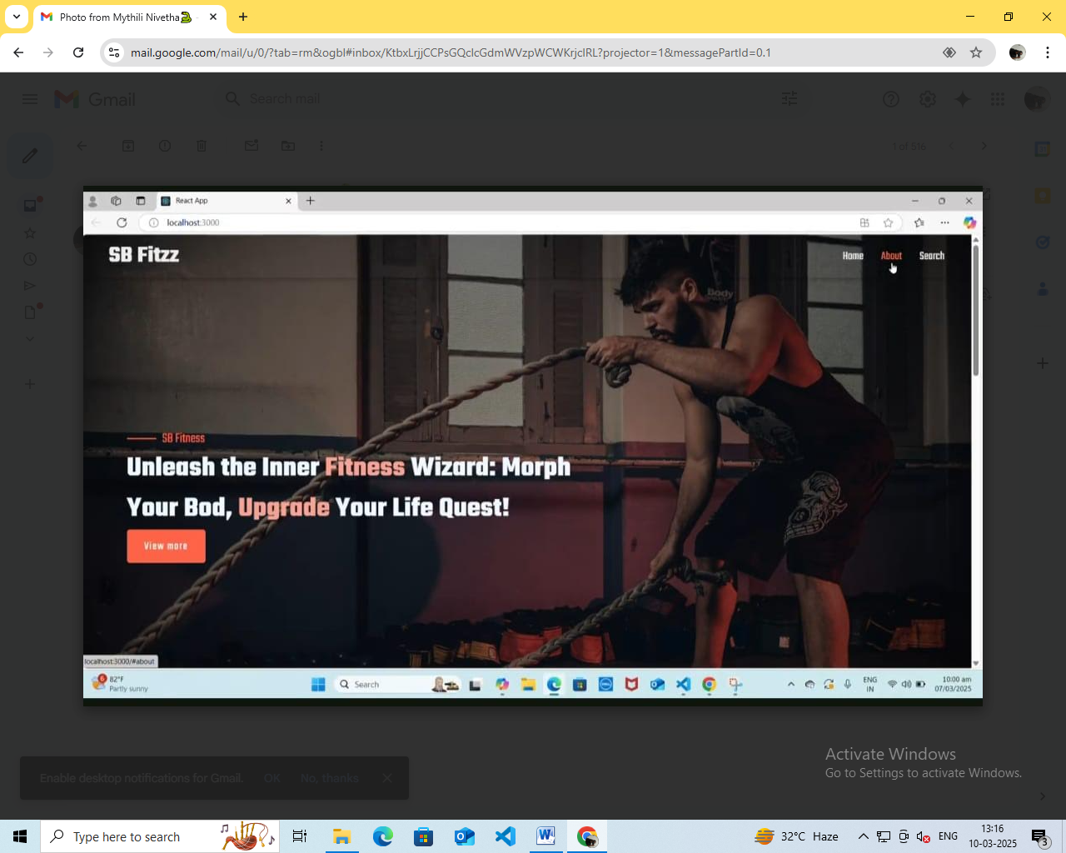

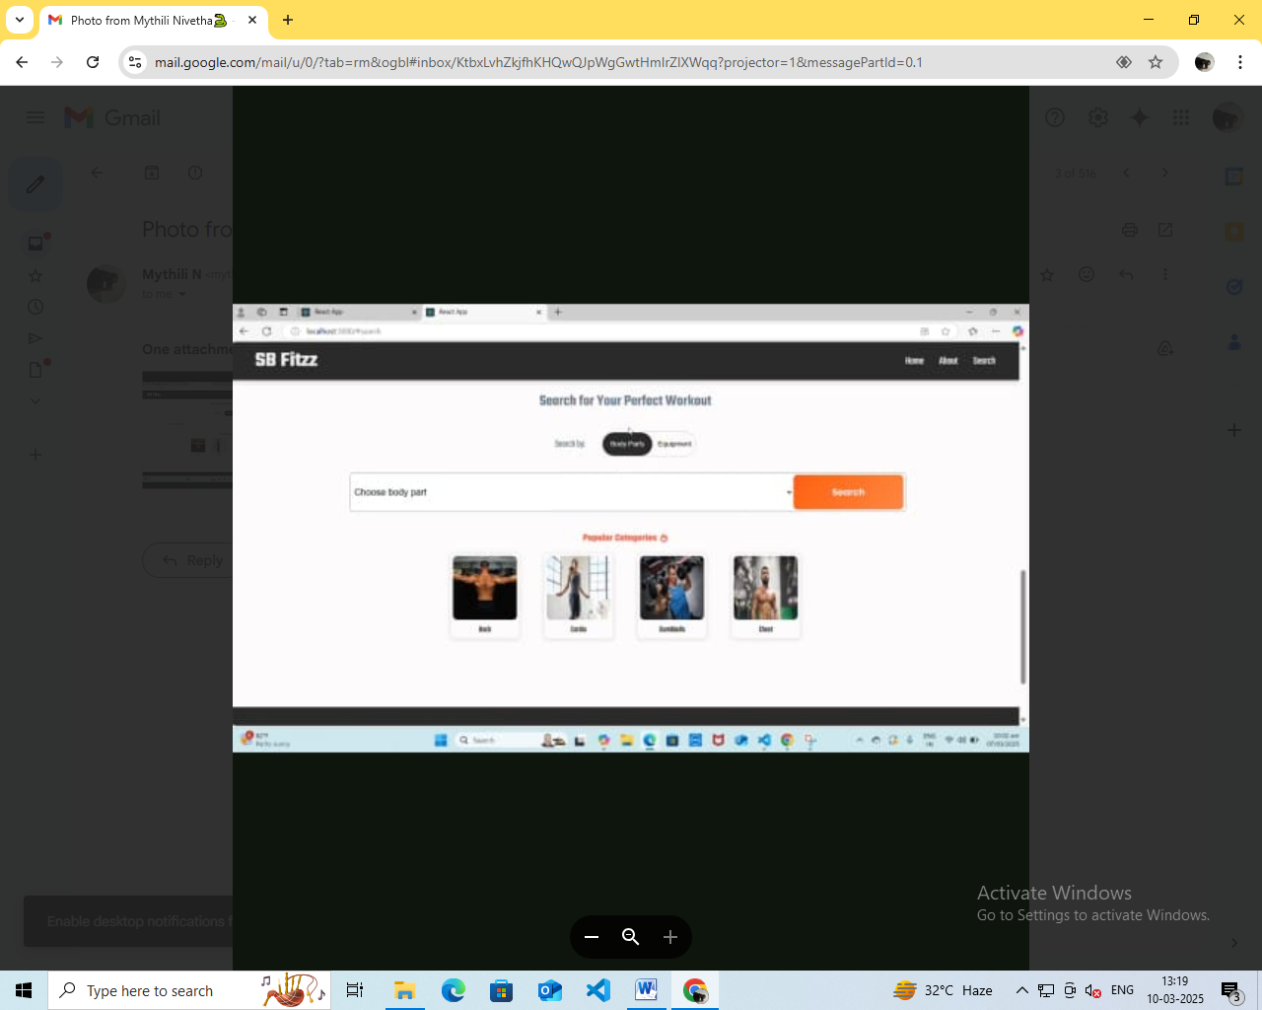

1. **Known Issues**

Slow Loading Times: Fitness websites, especially those with images, videos, workout tracking and community features can become resource heavy.

Addressing these known issues early in the development and testing phases will help ensure a smooth user experience, high user satisfaction and long term success for the Fitflex website.

1. **Future Enhancement**

These future enhancements aim to make the Fitflex fitness website a more comprehensice, personalized and engaging platform that combines technolopgy, wellness and community.

Description: Introduce features focused on mental wellness, such as meditation, mindfulness and stress-reducing activities.

Future Enhancement: Integrate with apps like Headspace or Calm for guided meditation sessions or relaxation execises that complement physical fitness routines.

Benefits: Fosters a holistic approach to fitness by addressing mental well-being along with physical health.